Using Mail Merge

Mail Merge

Mail Merge is a useful tool that allows users to easily produce multiple letters, labels, envelopes, nametags and more, using information stored in a list, database, or spreadsheet.
Mail merging is the process of generating personalized letters, labels or envelopes by merging two files; a main document such as a letter, envelope or mailing label with a data source or address book.
When you are performing a Mail Merge, you will need a Word document (you can start with an existing one or create a new one) and a recipient list, which is typically an Excel Workbook.

To use Mail Merge:
- Open an existing Word document, or create a new one.
- Click the Mailings tab.
- Click the Start Mail Merge command.
- Select Step by Step Mail Merge Wizard.
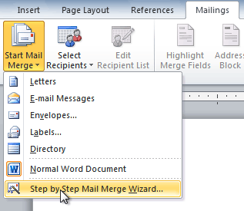
The Mail Merge task pane appears and will guide you through the six main steps to complete a merge. The following is an example of how to create a form letter and merge the letter with a recipient list.

Step 1:
- Choose the type of document you wish to create. In this example, select Letters.
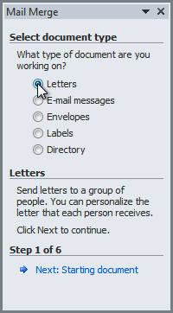
- Click Next: Starting document to move to Step 2.

Step 2:
- Select Use the current document.
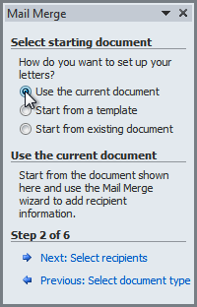
- Click Next: Select recipients to move to Step 3.

Step 3:
Now you'll need an address list so Word can automatically place each address into the document. The list can be in an existing file, such as an Excel workbook, or you can type a new address list from within the Mail Merge Wizard.
- From the Mail Merge task pane, select Use an existing list, then click Browse.
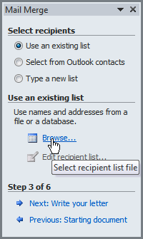
- Locate your file in the dialog box (you may have to navigate to a different folder), then click Open.
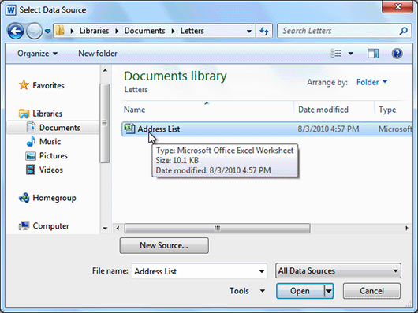
- If the address list is in an Excel workbook, select the worksheet that contains the list, then click OK.
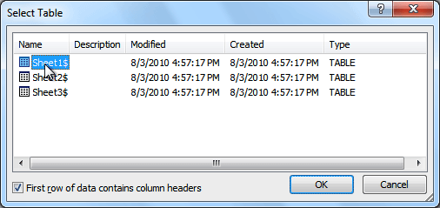
- In the Mail Merge Recipients dialog box, you can check or uncheck each recipient to control which ones are used in the merge. When you're done, click OK to close the dialog box.
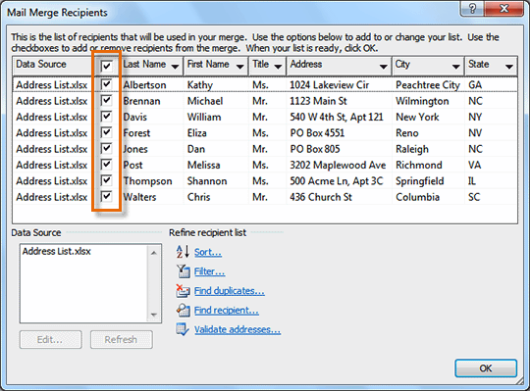
- From the Mail Merge task pane, click Next: Write your letter to move to Step 4.
If you don't have an existing address list, you can click the Type a new list button and click Create. You can then type your address list.

Step 4:
Now you're ready to write your letter. When it's printed, each copy of the letter will basically be the same, except the recipient data (such as the name and address) will be different on each one. You'll need to add placeholders for the recipient data so Mail Merge knows exactly where to add the data. If you're using Mail Merge with an existing letter, make sure the file is open.

To insert recipient data:
- Place the insertion point in the document where you wish the information to appear.
- Select Address block, Greeting line, Electronic postage, or More items from the task pane.
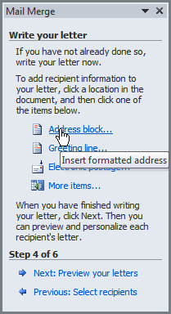
- Depending on your selection, a dialog box may appear with various options. Select the desired options, then click OK.
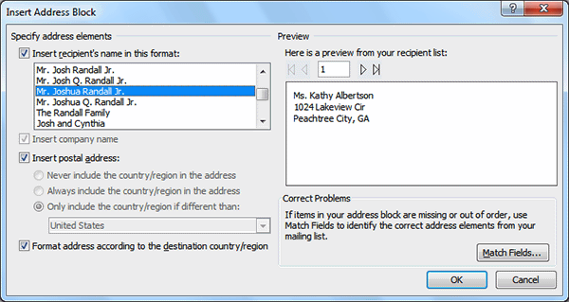
- A placeholder appears in your document. For example: «AddressBlock».
- Repeat these steps each time you need to enter information from your data record.
- From the Mail Merge task pane, click Next: Preview your letters to move to Step 5.
For some letters, you'll only need to add an Address block and Greeting line. Sometimes, however, you may wish to place recipient data within the body of the letter to personalize it even further.

Step 5:
- Preview the letters to make sure information from the recipient list appears correctly in the letter. You can use the left and right scroll arrows to view each document.
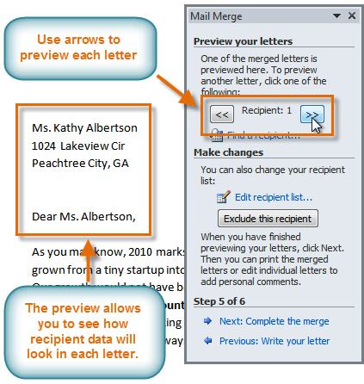
- Click Next: Complete the merge to move to Step 6.

Step 6:
- Click Print to print the letters.
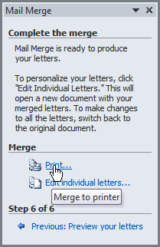
- The Merge to Printer dialog box opens. Click All, then click OK.
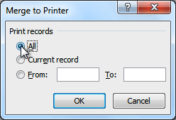
- The Print dialog box will appear. Adjust the print settings if needed, then click OK.
